Store Keeper Training Guide
Inventory & Asset Management in the ERP
Covers: Inventory (Item) Register, Asset Register, Goods Received Notes (GRN), Store Requisitions, issuing to staff, returns, asset transfers, disposal and physical counts.
How to use this guide: each step names the exact button or menu to click (in bold). Grey boxes marked [ SCREENSHOT ] say what to capture and paste in. Delete this note before issuing.

1. The big picture
What | Where it lives | Examples
Consumables (counted by quantity) | Inventory Register | Paper, pens, toner, cleaning supplies
Assets (each unit tagged individually) | Asset Register | Laptops, phones, chairs, desks
Goods coming in | Goods Received Note (GRN) | Delivery against a Purchase Order
Goods going out | Store Requisition | Staff request for an item or asset
Who holds what | Items Issued to Staff | Custody list per employee

Rule of thumb:
- GRN confirmed: stock and assets are added to the registers automatically.
- Store Requisition posted: stock is deducted, or the asset is marked Issued to the employee, automatically.
- Return Item: the asset becomes Available again automatically.
You do not create Item cards or Fixed Asset cards. Finance creates those. Your job is to receive, store, issue, count and take back.

1.1 Two kinds of stock
 | Consumables | Assets
Examples | Paper, hand soap, toner | Laptops, monitors, chairs
Tracked in | Inventory Register | Asset Register
Counted by | Quantity | One row per unit, each with a unique Tag Number
Comes back? | No, it is used up | Yes, it is returned later
Master record | Item card (created by Finance) | Fixed Asset card (created by Finance)

1.2 The life of stock, step by step
Step | What happens | Who
1. Buy | A Purchase Order is raised and released | Procurement
2. Receive | Click Create GRN on the order. The GRN lists what should arrive, one line per unit | Store Keeper
3. Check and confirm | Check the delivery against the GRN, fill in model, serial no. and category, click Confirm GRN. Assets become tagged rows in the Asset Register (Available). Consumables become rows in the Inventory Register | Store Keeper
4. Shelve | Put goods in their location and stick the Tag Number label on assets | Store Keeper
5. Request | An employee creates a Store Requisition | Employee
6. Approve | Click Approve for Issue | Store Manager
7. Issue | Pick the Tag No. for assets, hand over, click Post Store Requisition. Asset becomes Issued to the employee; consumable quantity is reduced; both appear on Items Issued to Staff | Store Keeper
8. Return | Click Return Item. The asset becomes Available again | Store Keeper
9. Move or dispose | Asset Transfer moves an asset to a new person or place. Disposal needs a Disposal Approver | Store Keeper / Approver
10. Count | Compare the shelf with the system. The difference is the Variance | Store Keeper, reviewed by Store Manager

1.3 Who does what
Role | Responsibility
Employee | Requests items or assets
Store Manager | Approves requisitions; reviews counts and adjustments
Store Keeper | Receives, shelves, issues, takes back and counts
Finance | Creates item and asset cards; depreciation and accounting

Important: before issuing consumables, make sure the Physical Count has been entered on the Inventory Register row. Stock is deducted from rows that have a Physical Count above 0.

2. Logging in and finding your way
- Open the ERP in your browser and sign in with your own user name and password.
- You land on the Store Keeper role centre. The tiles show work waiting for you: Open Store Requisitions, Requisitions Released to Issue, Pending Goods Receipts, Open Asset Transfers, Asset Transfers to Execute, Approved Purchase Orders, Purchase Invoices Ready.
- The top bar has three drop-downs. Store Operations: Store Requisitions, Goods Received Notes, Items Issued to Staff, Issue and Return History, Asset Transfers. Assets: Asset Register, Asset Register Summary, Asset Categories, Asset Types. Inventory: Inventory Register, Inventory Register Summary, Inventory Categories.
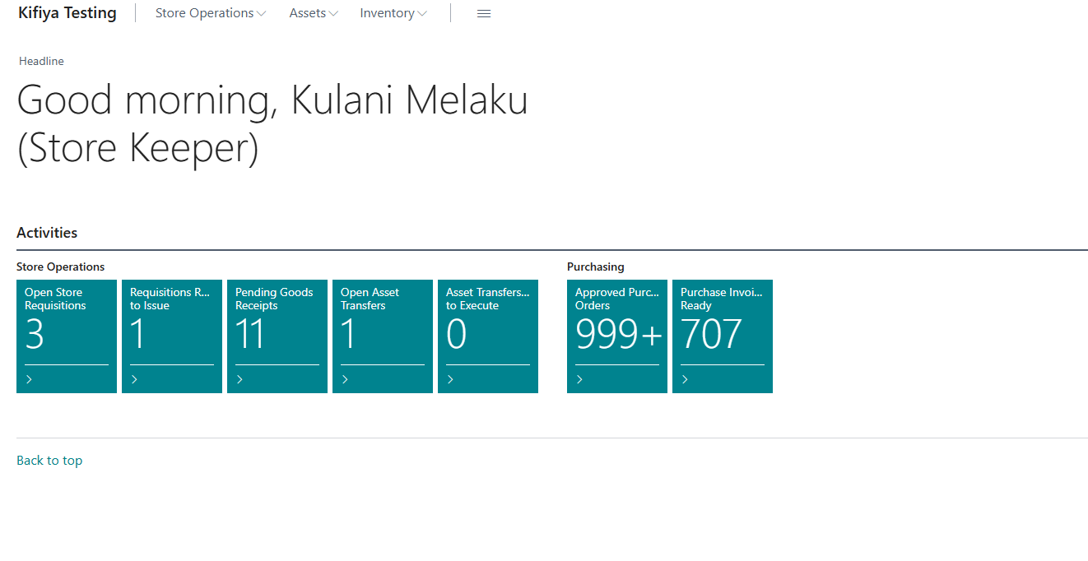
Store Keeper home page: a one-line greeting with your name and role, then the three drop-downs (Store Operations, Assets, Inventory) and the tiles showing work waiting.

3. One-time setup lists (Categories and Types)
Check these before you start. New codes are also created automatically when a GRN is confirmed, but keep the names tidy.
- Click Asset Categories to see or rename asset category codes.
- Click Asset Types to see or rename type codes (Laptop, Desktop, Chair, etc.). The type becomes part of the Tag Number.
- Click Inventory Categories for consumable category codes.
- To add a code, go to the blank row at the bottom, type the Code and Description, press Enter.
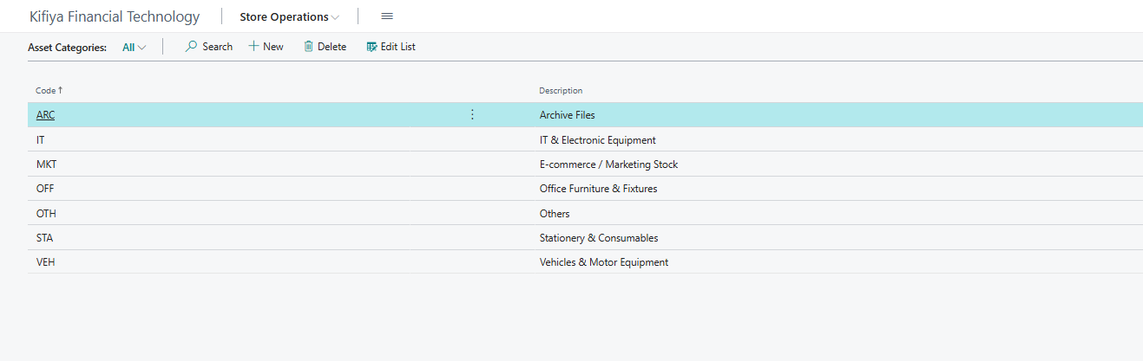
Asset Categories: each code has a description. This is what appears as the Asset Register description when the class is used.
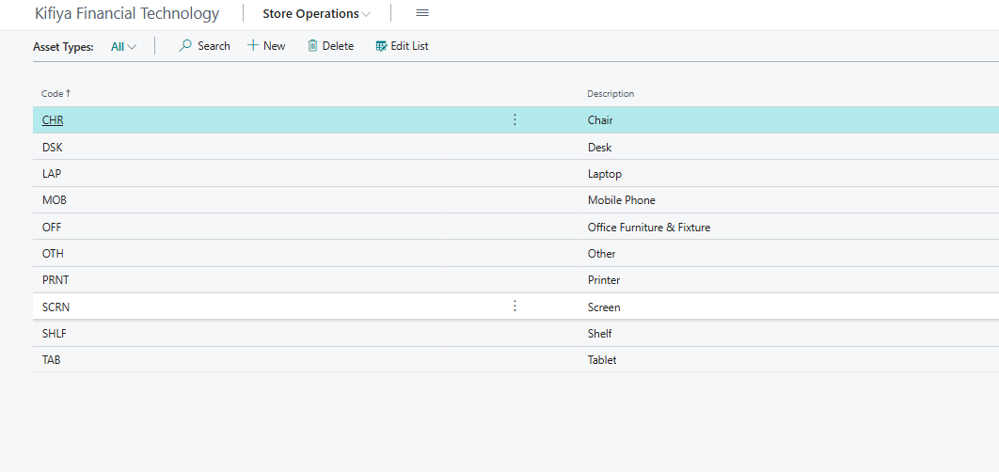
Asset Types: each code has a description, e.g. MOB = Mobile Phone. The Asset Register Description comes from the type.

4. Inventory (Item) Register: consumables
Opened from: Store Operations > Inventory Register.
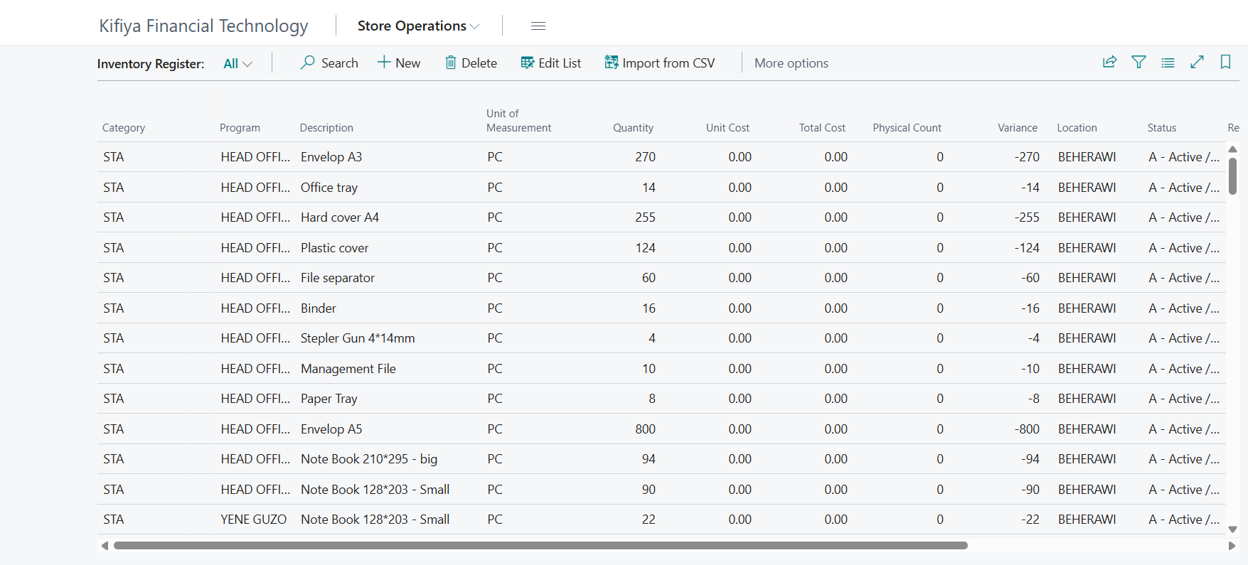
Inventory Register list: Quantity, Physical Count and Variance columns.

4.1 What the columns mean
Column | Meaning
Category / Description / Unit of Measure | What the item is
Quantity | What the system says we should have (book quantity)
Physical Count | What you actually counted on the shelf
Variance | Difference between the two. Anything other than 0 needs an explanation
Item No. | Link to the Item card Finance created
Last Counted Date | Stamped when you use Mark Counted Today

4.2 How stock gets in
Normally you do not type stock in. Confirming a GRN (section 6) creates the rows. For an opening load only, use Import from CSV:
- On the Inventory Register click Import from CSV (action bar at the top).
- Choose the file. Column order must be: Category, Program, Description, UoM, Quantity, Unit Cost, Physical Count, Location, Status, Remarks.
- Check the rows loaded and correct any mistakes directly in the list.
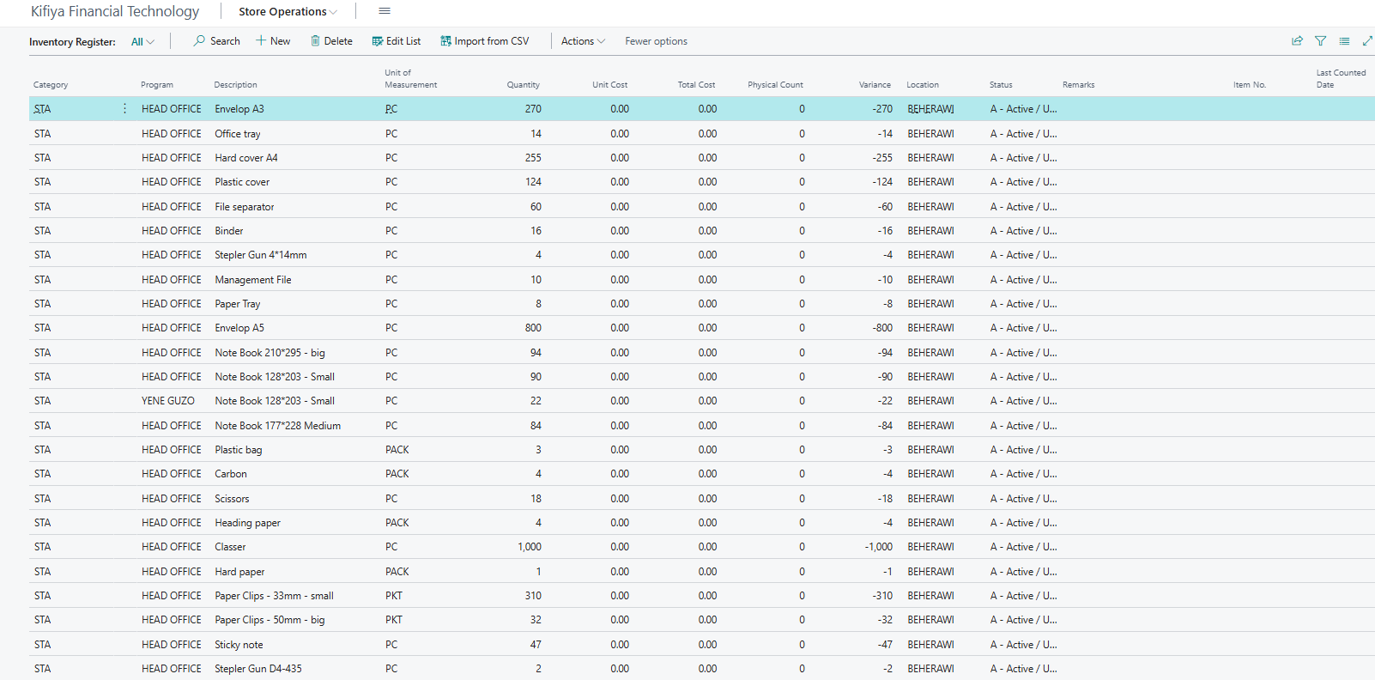
Inventory Register: Import from CSV is in the action bar at the top. Use it for an opening load only.

4.3 Counting stock
- Count the shelf. Type the number in the Physical Count column of that row.
- Look at Variance. If it is not 0, recount, then write the reason in Remarks.
- Select the counted rows and click Mark Counted Today.
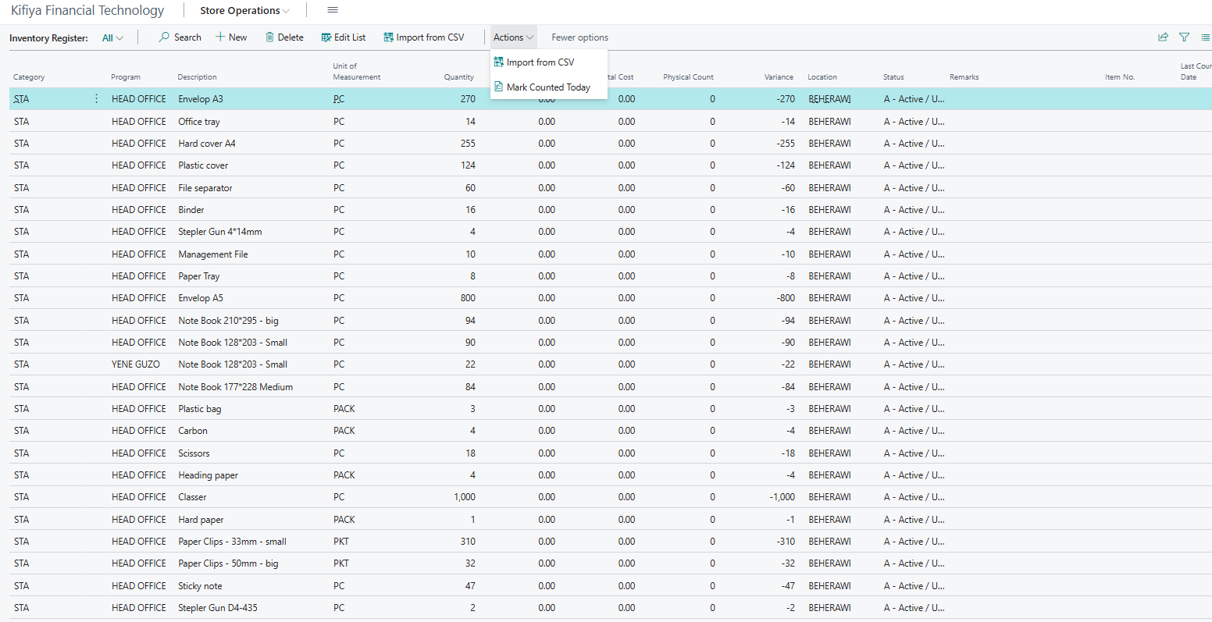
Inventory Register: Mark Counted Today is in the Actions menu. Select the counted rows first.
On this screen the column is called Unit of Measurement, and the asset list calls Category "Asset Class" and Tag No. "Tag Number". Same thing.

Do not edit Quantity to hide a variance. Report differences to the Store Manager, who decides on adjustments.

4.4 Inventory Register Summary
A GRN adds one register row per unit received, so the Inventory Register can run to many rows for a few items. The summary rolls them up to one row per item.
- From the Store Operations menu click Inventory Register Summary.
- Each row shows the total Quantity, Physical Count, Variance (highlighted when not 0), Average Unit Cost and Total Cost.
- Select a row and click Show Register Rows to see the individual register rows behind it. Click Refresh to recalculate.
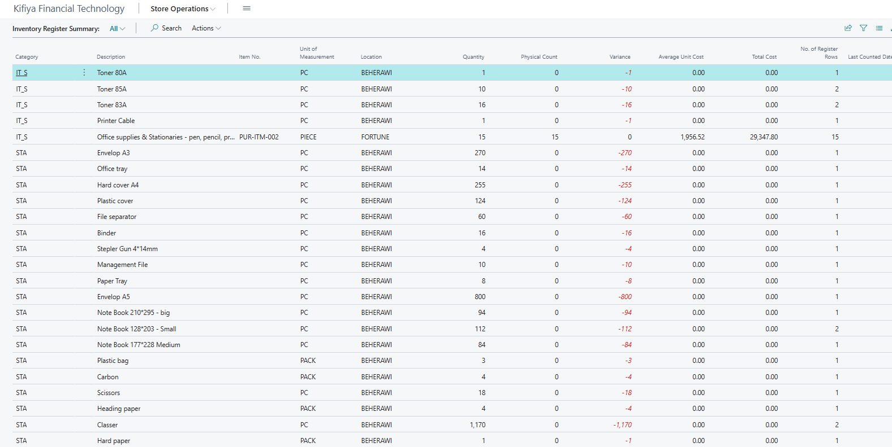
Inventory Register Summary: one row per item, with quantity, physical count, variance and cost.

5. Asset Register: tagged assets
Opened from: Store Operations > Asset Register.
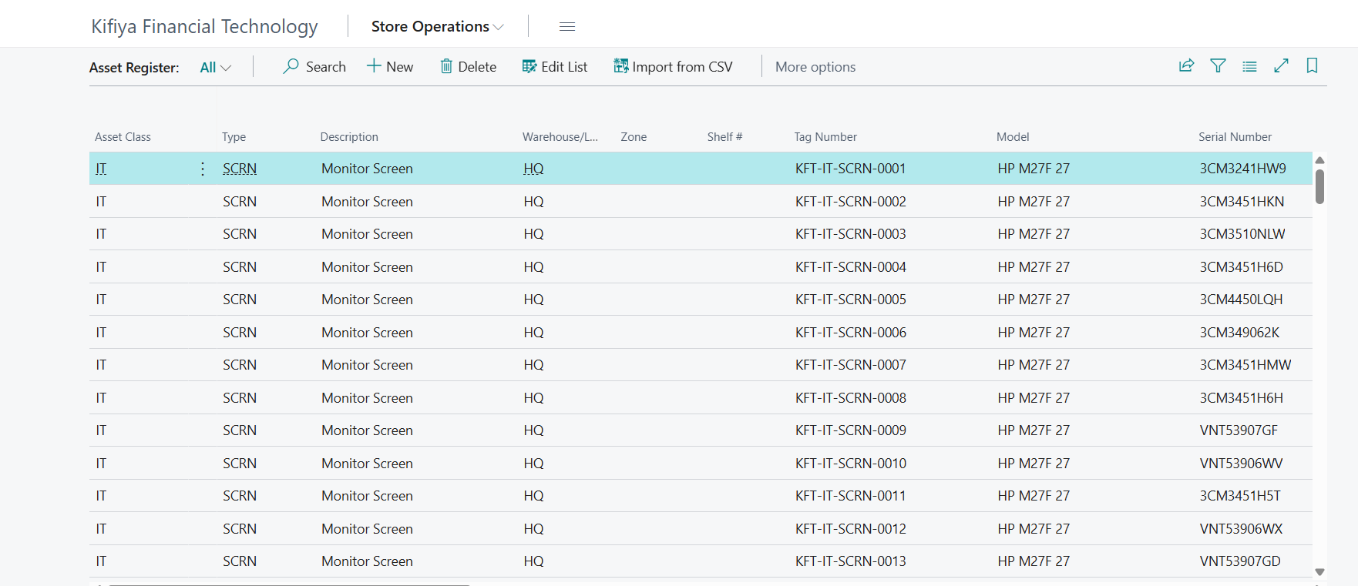
Asset Register list: one row per physical unit, each with its own Tag Number.

5.1 Key columns
Column | Meaning
Tag Number | Unique tag for each physical unit, e.g. KFT-<Class>-<Type>-<Serial>. Stick this label on the asset
Asset Class / Type / Model / Serial Number | Description of the asset
Location Code / Zone Code / Shelf No. | Where it is stored
Availability Status | Available, Issued or Disposed. Only Available units can be requested
Issued Date / Assigned To | Filled automatically when issued
Return Date / Return To | Filled automatically when returned
Fixed Asset No. | Link to the Fixed Asset card owned by Finance
Disposal columns | Used only for the disposal process (section 10)

5.2 Giving each unit its own tag
If one row covers several units (for example Physical Count = 12):
- Select the row.
- Click Split into Tagged Units. The system creates one row per unit, each with its own Tag No. A message tells you how many were created.
- If a row has no Tag No., select it and click Generate Tag No. (the Category must be filled in).
- Write the Tag No. on a label and stick it on the physical asset.
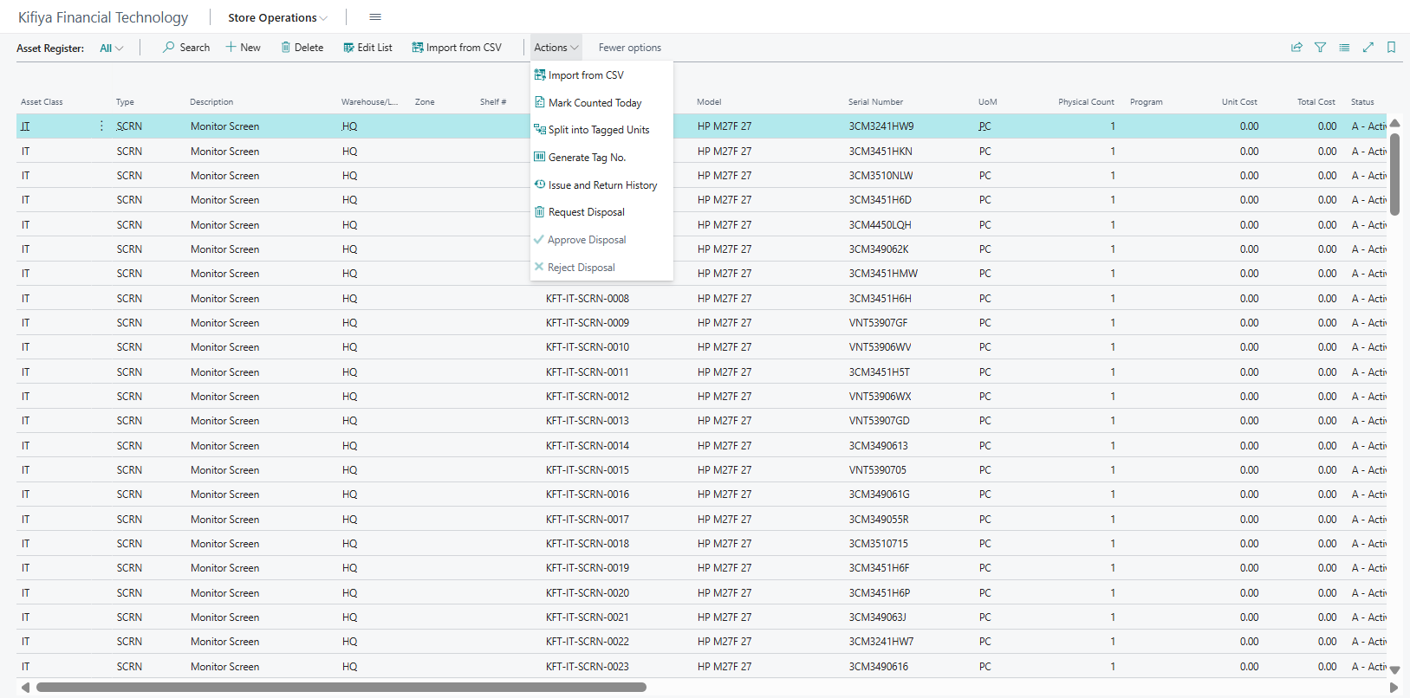
Asset Register Actions menu: Split into Tagged Units, Generate Tag No., Mark Counted Today, Issue and Return History and the disposal actions.

5.3 Summary view
Click **Asset Register Summary** for totals by class, type, description and model (for example "12 Duos / Samsung"). Click a total to drill down to the individual units.
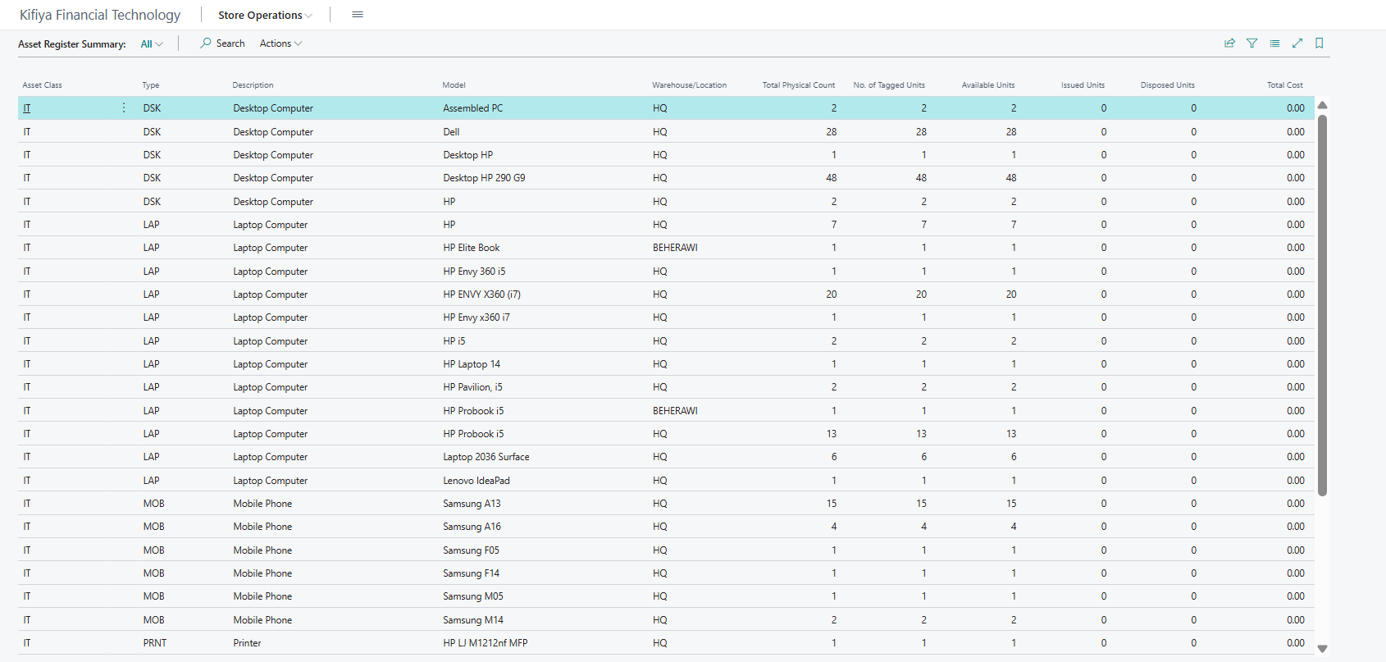
Asset Register Summary: totals by class, type, description and model, with available and issued units.

5.4 Counting assets
- Walk the store and check each tagged unit physically.
- Select the verified rows and click Mark Counted Today.
- Record anything missing or damaged in Remarks and tell the Store Manager.

6. Receiving goods: Goods Received Note (GRN)
A GRN is created from a Purchase Order or from a Posted Purchase Invoice. Never receive goods without one.

6.1 Create the GRN
Option A: from an approved Purchase Order
- On the home page click the Approved Purchase Orders tile and open the released order matching the delivery.
- Open the Print/Send tab in the action bar and click Create GRN. The GRN number is stamped on the order.
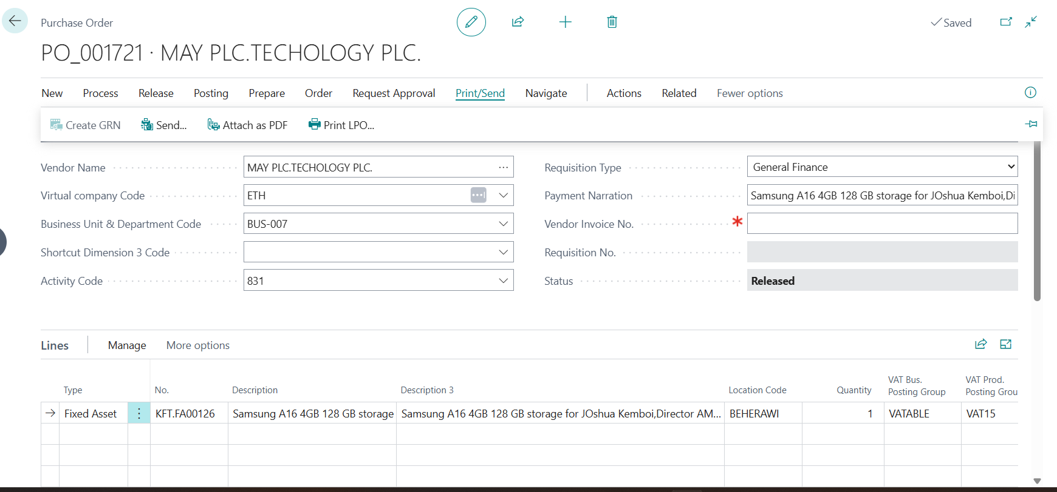
Purchase Order: open the Print/Send tab, then click Create GRN.
Option B: from a Posted Purchase Invoice
- On the home page click the Purchase Invoices Ready tile and open the invoice.
- On the Process tab of the action bar click Create GRN. It is enabled only while GRN Generated is off.
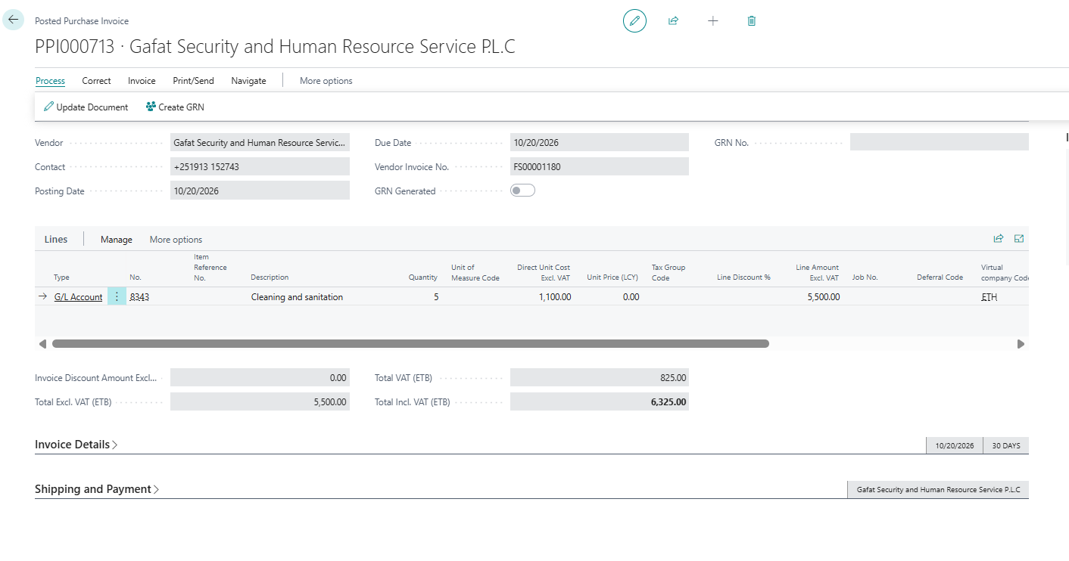
Posted Purchase Invoice: Create GRN is on the Process tab. GRN Generated shows whether one has been made.
Automatic split: any Fixed Asset or Item line with more than one unit is split into one line per unit (12 laptops become 12 lines). Lines with fractional quantities (for example litres) are not split.

6.2 Check and complete the GRN
- Click Goods Received Notes and open your GRN (status Pending).
- Check the physical delivery against each line. Correct Quantity To Receive if less arrived.
- For each Fixed Asset line fill in Category, Asset Type, Model and Serial No. (read the serial from the box or label).
- For Item lines fill in Category if it is blank.
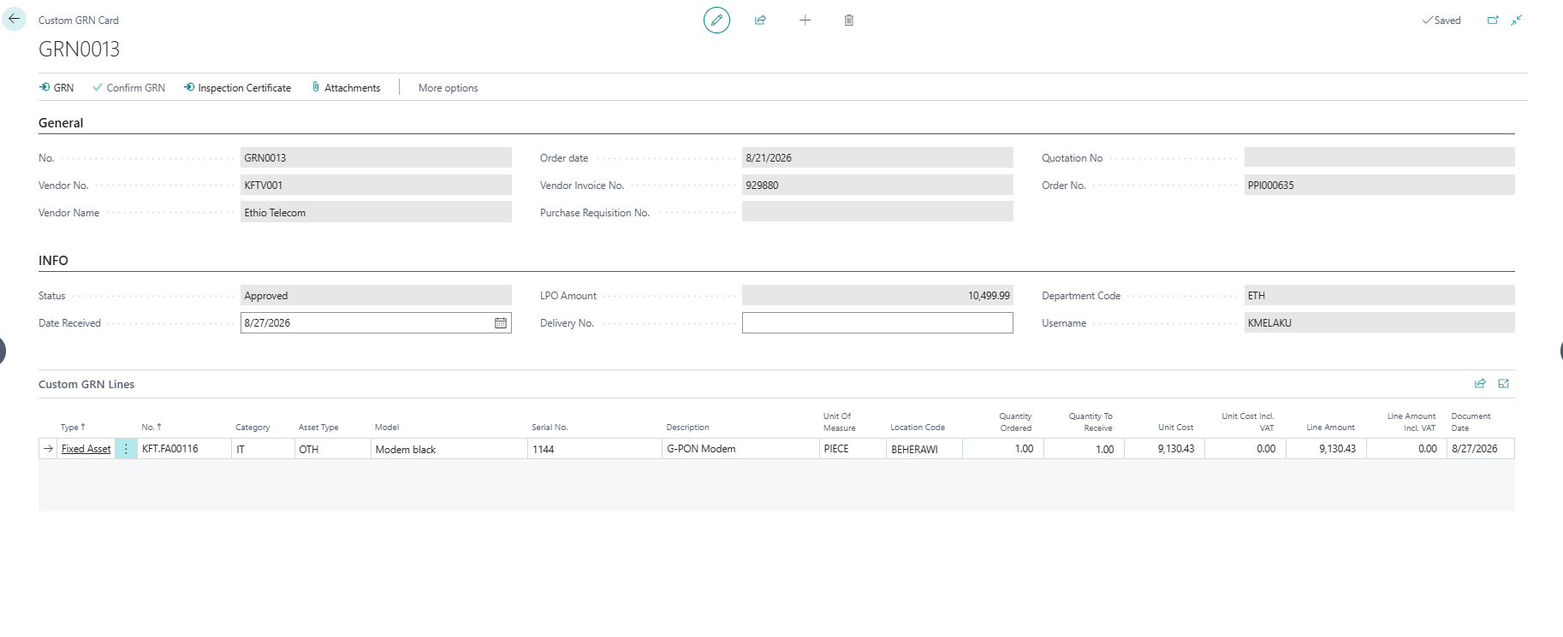
GRN lines completed before confirming: Category, Asset Type, Model, Serial No. and Location Code filled in. Scroll right for the VAT columns.
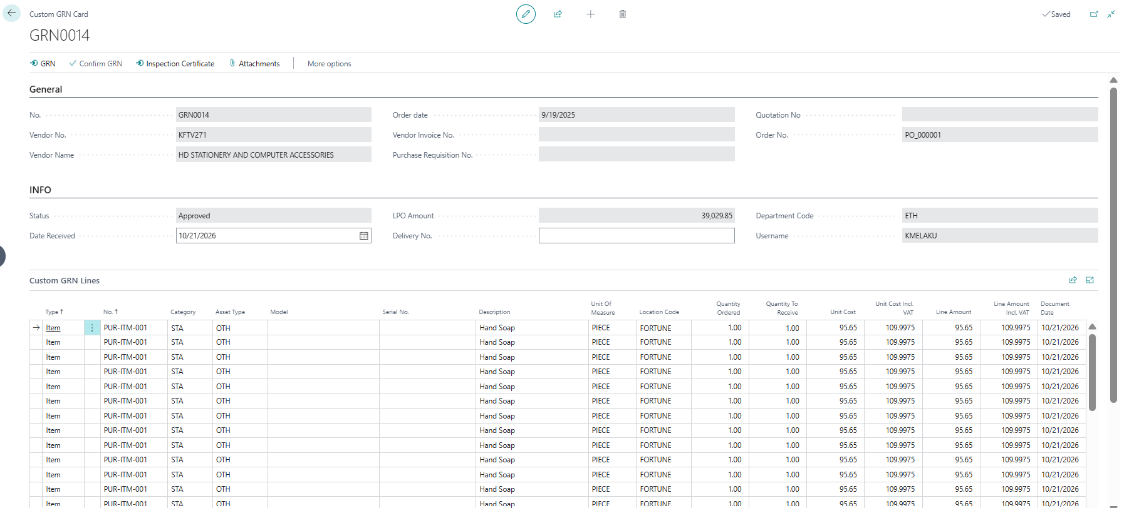
A GRN from a purchase order with Item lines: one line per unit, with Location Code and the Unit Cost Incl. VAT and Line Amount Incl. VAT columns.

6.3 Confirm the GRN
- When everything is correct click Confirm GRN (Process group of the action bar). Status changes from Pending to Approved.
- Fixed Asset lines now appear in the Asset Register, each with an automatic Tag No. and Availability = Available.
- Item lines now appear in the Inventory Register with Quantity = Physical Count = quantity received.
- Open both registers and check the new rows. Tag the assets and shelve everything (fill in Zone and Shelf No.).
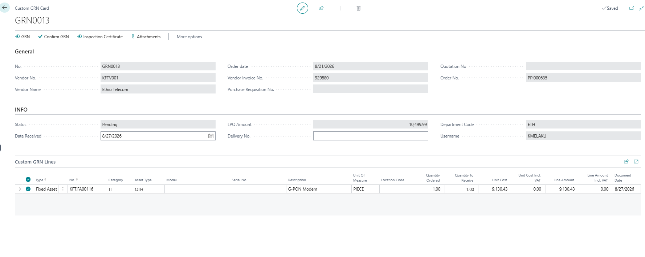
A GRN that is still Pending: Confirm GRN is enabled in the action bar. Check Category, Asset Type, Model, Serial No. and Location on the lines first.
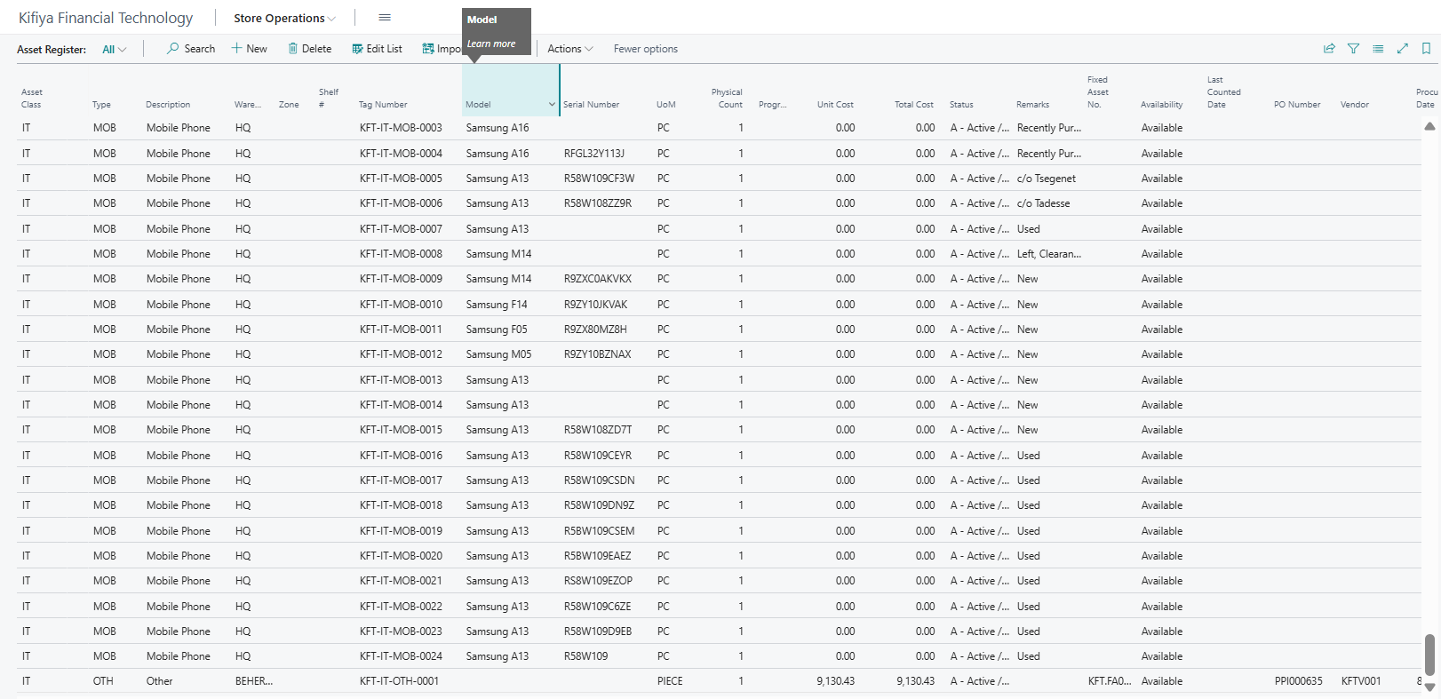
Asset Register after confirming a GRN: the new unit appears at the bottom with its tag, PO number, vendor and Available status.
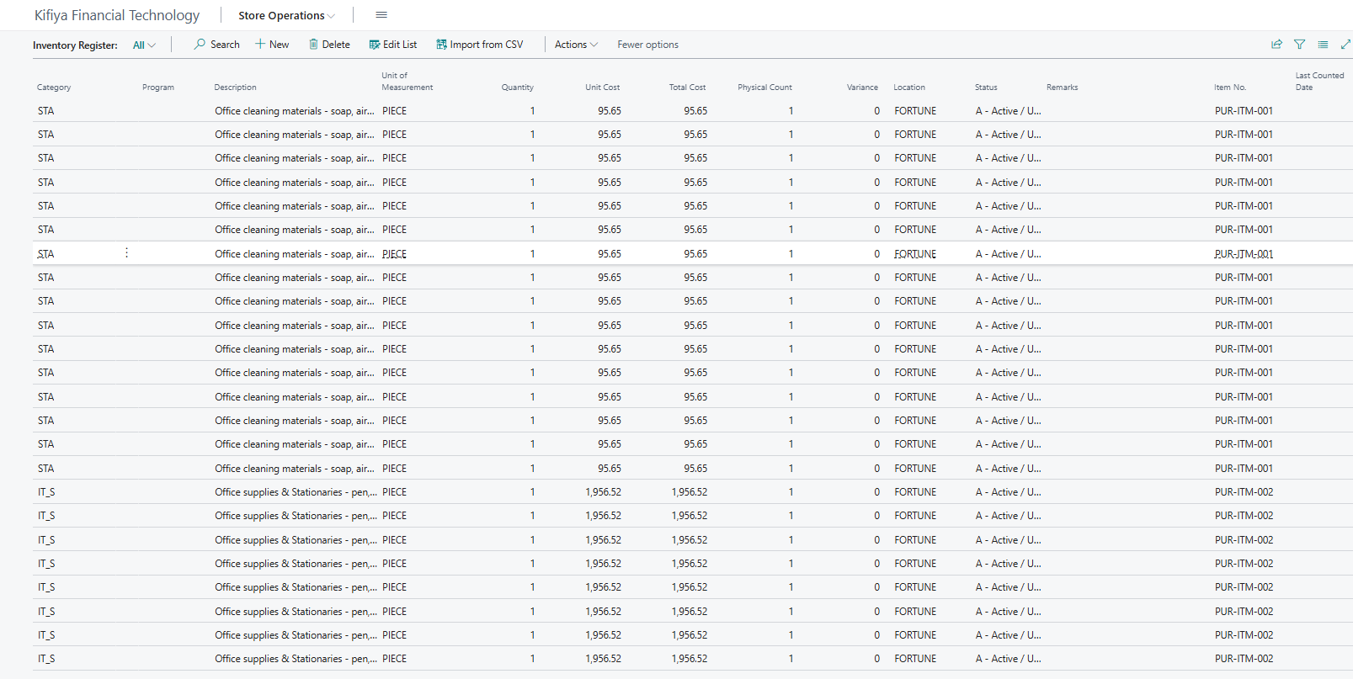
Inventory Register after confirming a GRN with Item lines: new rows with Item No., location, unit cost and quantity. Physical Count starts equal to Quantity, so Variance is 0.
There is no separate approval after Confirm GRN, so check carefully before clicking it.

7. How an employee request is processed (Request, Approval, Issue)

7.1 The full flow
Step | Who | What happens | System result
1 | Employee | Creates a Store Requisition for the item or asset they need | Status: Open
2 | Store Manager | Reviews it and clicks Approve for Issue | Status: Released; approver and date stamped
3 | Store Keeper | Sees it in the "Requisitions Released to Issue" tile; checks stock; for an asset picks the Tag No. | Only Available tags can be chosen
4 | Store Keeper | Hands over the goods, employee signs, clicks Post Store Requisition | Status: Posted
5 | System | Records custody and updates the registers | See 7.4

Nothing leaves the store until the Store Manager has approved. The Store Manager cannot approve a requisition they created themselves.

7.2 Employee: create the requisition
- Open Store Requisitions and click New.
- Fill in Employee No., Request Description and the other required header fields.
- In the lines choose the type and No. (the item or asset) and enter the Quantity.
- Leave the requisition in status Open. The Store Manager will see it.
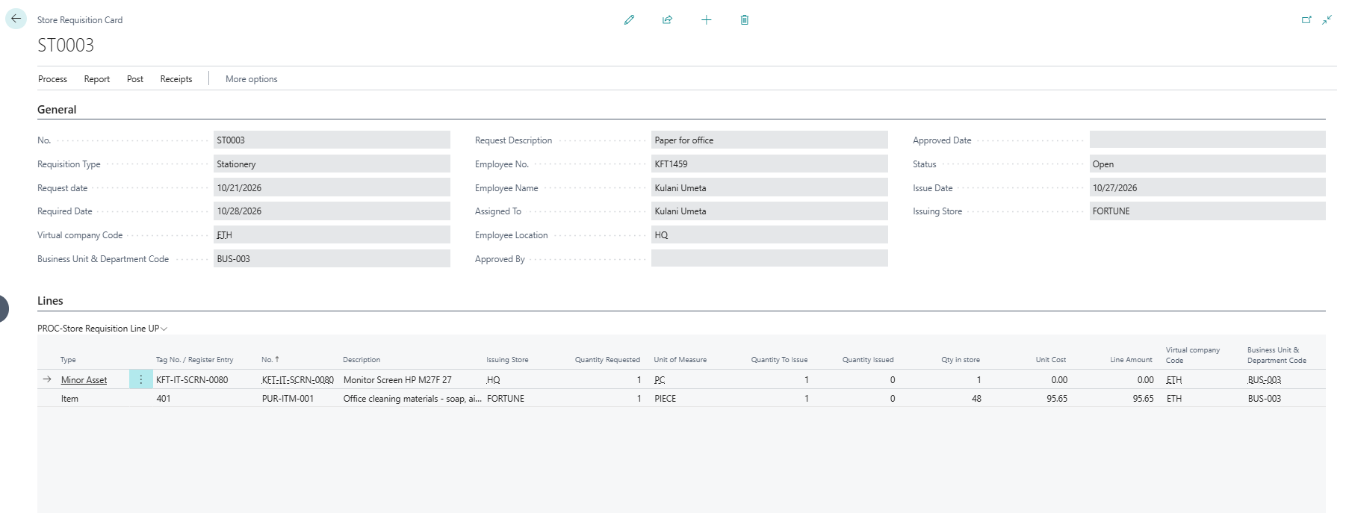
Employee: a requisition with an asset line and an item line. Set the Type, then pick from the register in the Tag No. / Register Entry column; the rest of the line fills in, including Qty in store from the register.
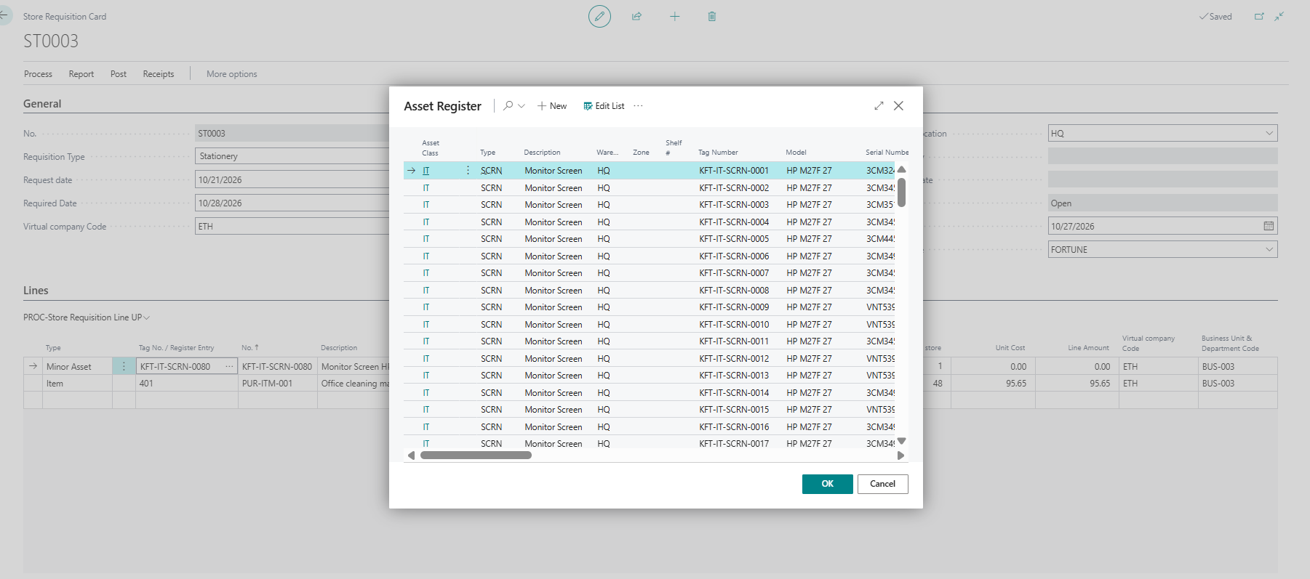
Asset line: click the Tag No. / Register Entry field and its lookup opens the Asset Register. Pick the unit you want and the rest of the line fills in.
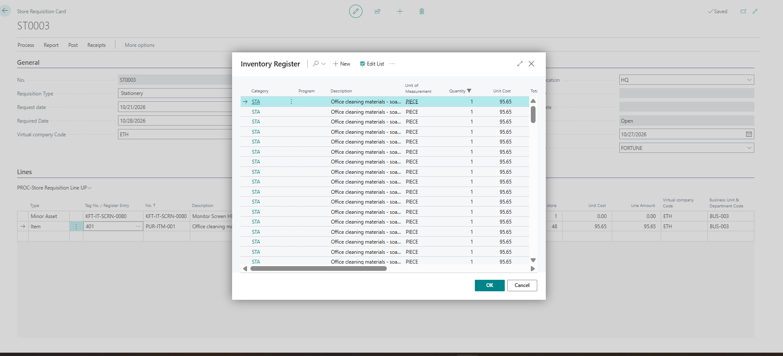
Item line: the same field opens the Inventory Register for stock items. Pick the row and the line fills in.

7.3 Store Manager: approve
- Click Store Requisitions and open the requisition (status Open).
- Check the request is reasonable (right person, right item, right quantity).
- Click Approve for Issue. Status changes to Released and your name and the date are stamped under Approved By / Approved Date.
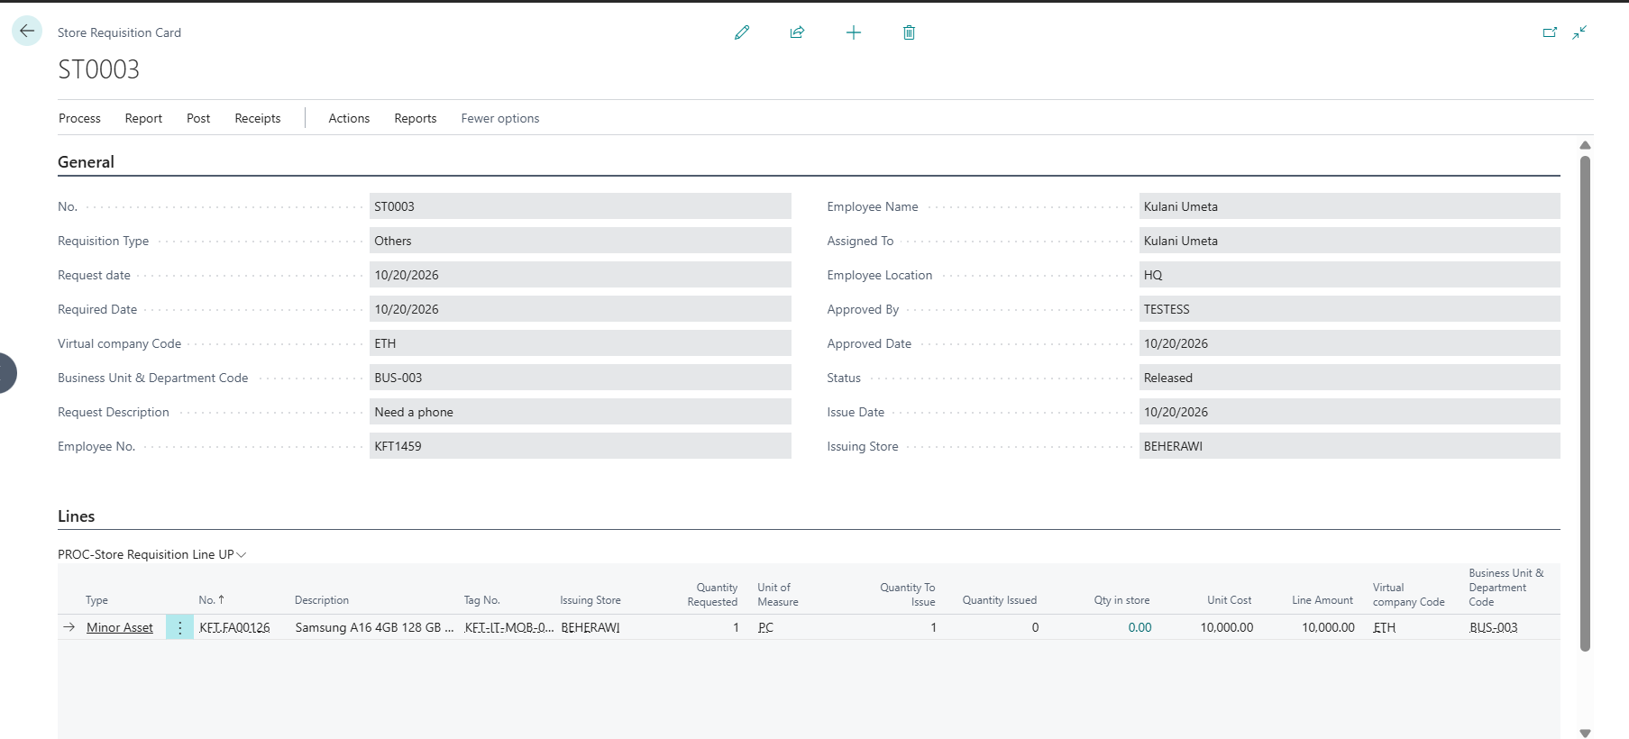
After the Store Manager approves: Status is Released, and Approved By and Approved Date are filled in.
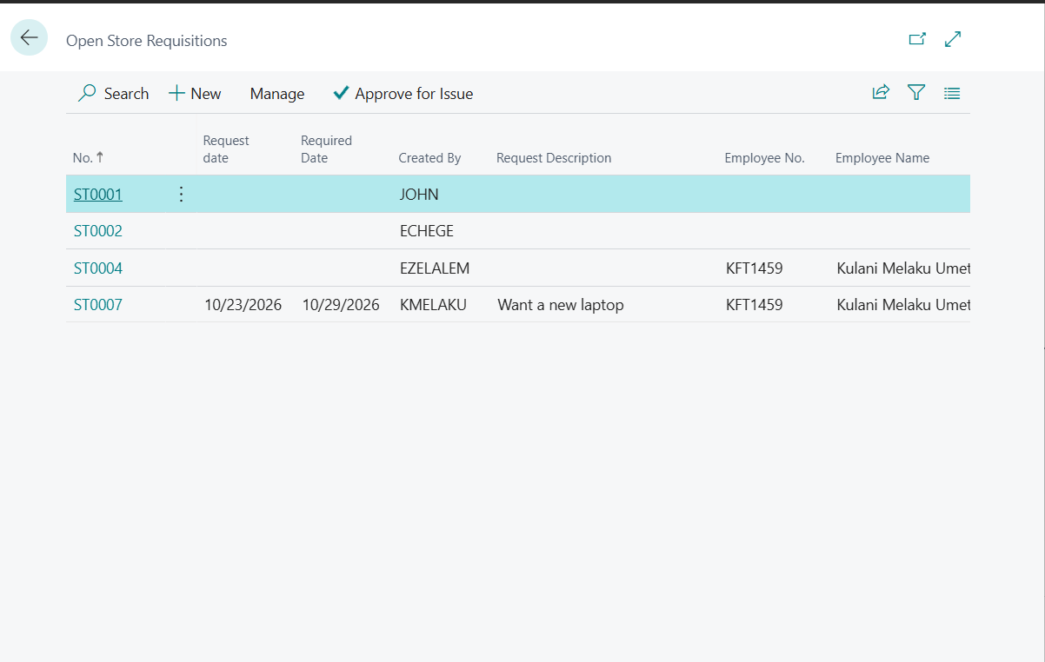
Store Manager: the Requisitions Awaiting Approval list shows every open requisition from all staff, who created it, and the employee full name. Select one and click Approve for Issue.
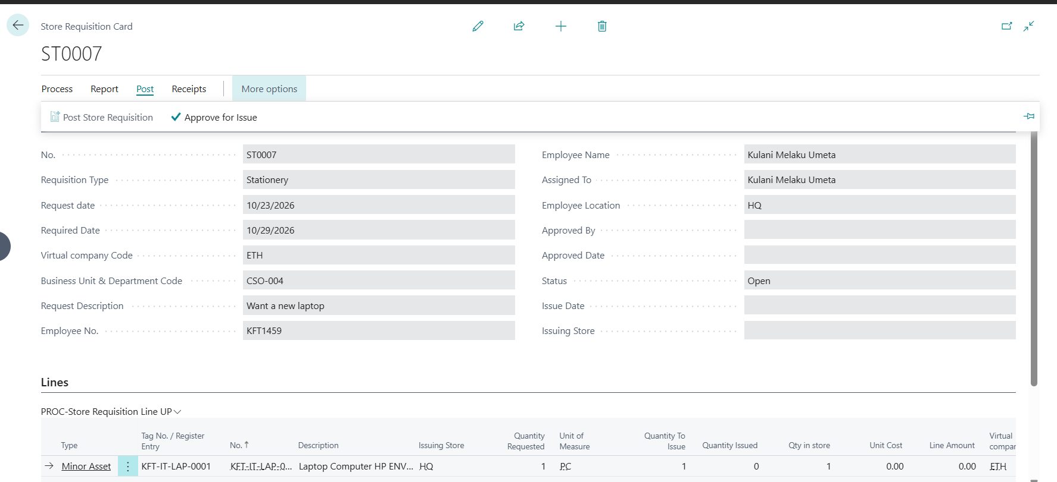
An open requisition: Approve for Issue is enabled for the Store Manager, and Post Store Requisition is greyed out until it is approved.

7.4 Store Keeper: issue and post
- On your home page the Requisitions Released to Issue tile shows approved requisitions waiting. Click it.
- Open the requisition. For an asset, enter the Tag No. on the line. The lookup shows only Available units; one already issued or disposed is rejected.
- Hand over the goods and have the employee sign the printed requisition.
- Click Post Store Requisition (on the card the button is called Post Store Requisition-new).
- Click Items Issued to Employee to confirm the custody rows were created.
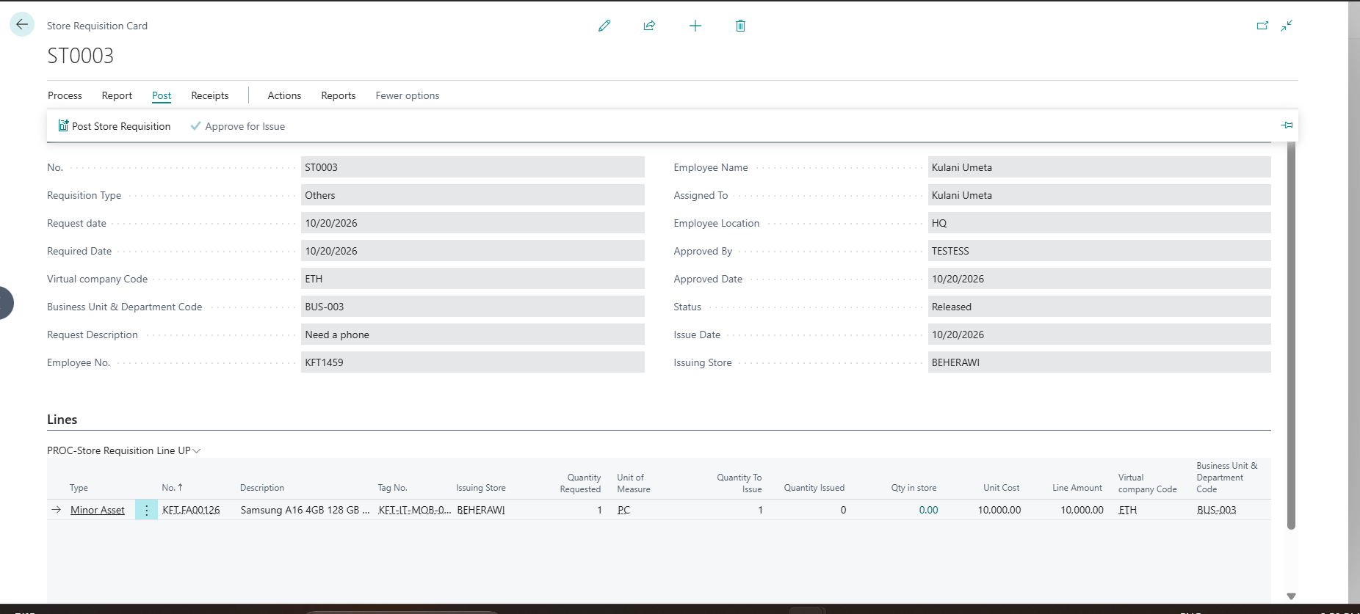
Store keeper: the Post tab shows Post Store Requisition. The line carries Tag No., Issuing Store, Unit of Measure, Unit Cost and quantities.
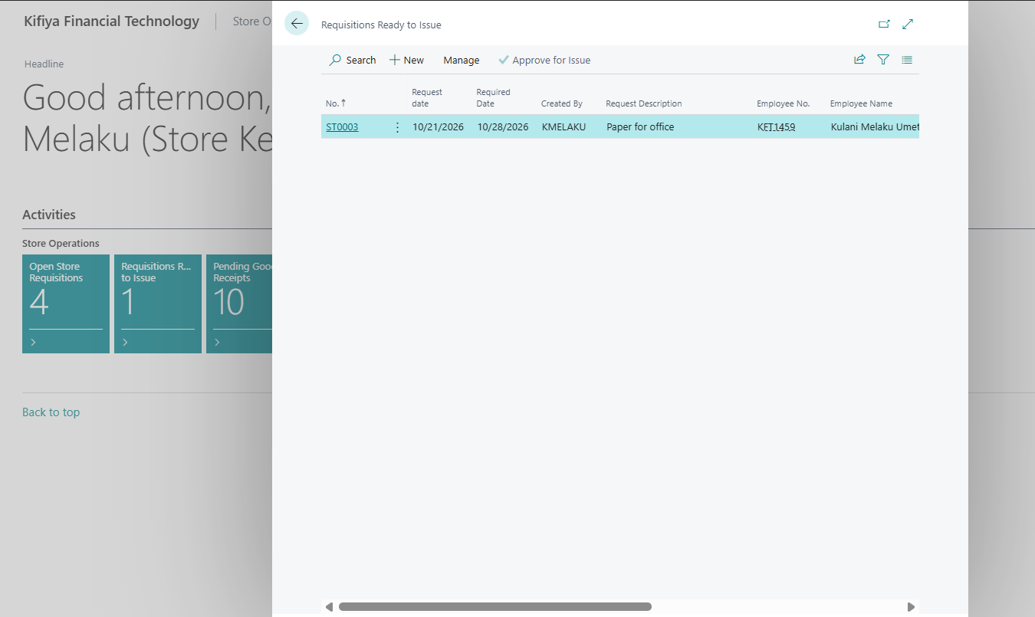
Store keeper: clicking the Requisitions Ready to Issue tile (or the menu entry Requisitions to Issue) lists the approved requisitions waiting to be handed over. Open one, check the tag or item, hand it over and click Post Store Requisition.

7.5 What the system does when you post
Line type | Result
Asset with a Tag No. | Asset Register row: Availability = Issued, Issued Date = today, Assigned To = employee. Added to the employee custody list
Consumable (no tag) | Quantity and Physical Count in the Inventory Register are reduced (oldest rows first). Recorded against the employee. Nothing is expected back

Asset lines must have a Tag No. If it is blank the Asset Register is not updated and the unit still shows Available.

Asset Register after posting: the laptop shows Availability = Issued, the Issued Date, and Assigned To = the employee. Filter the list by description (here "laptop") to find the unit.

8. When an employee returns an item or asset
- Click Items Issued to Staff in the menu (or Items Issued to Employee from the requisition).
- Find the employee's row for the returned item (filter by Employee No. or Tag No.).
- Inspect the asset: working, complete, accessories present, tag and serial match the row.
- Select the row and click Return Item. Follow any prompt.
- The system sets the Asset Register row back to Available, fills Return Date (today) and Return To (your user ID), and clears Assigned To.
- Put the asset back on its shelf. If it is damaged, note it in Remarks on the Asset Register row and tell the Store Manager.
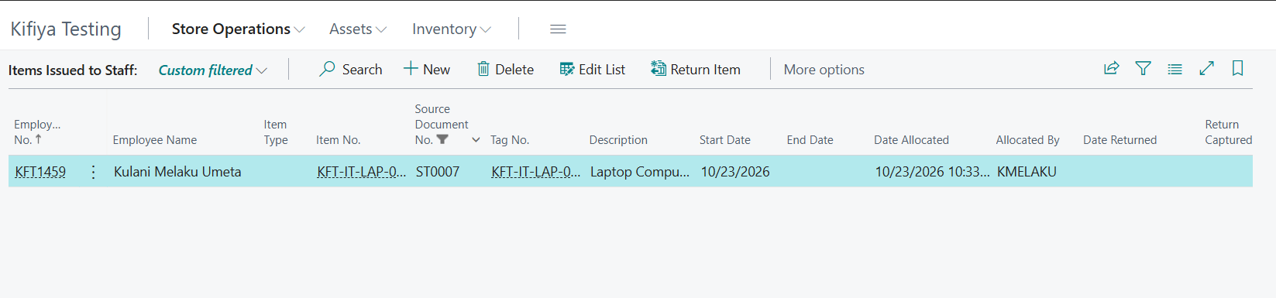
Items Issued to Staff before the return: the employee row (with Employee Name) is selected and Return Item is enabled. The End Date is blank.
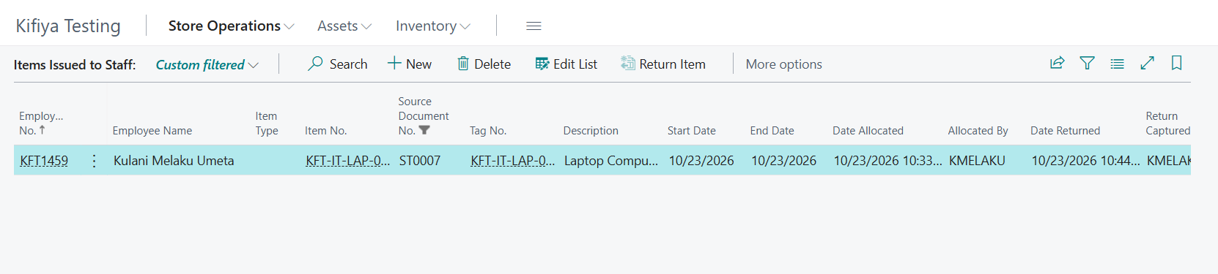
After clicking Return Item and confirming: End Date is filled in with today, Date Returned and Return Captured By are set, and Return Item is greyed out.

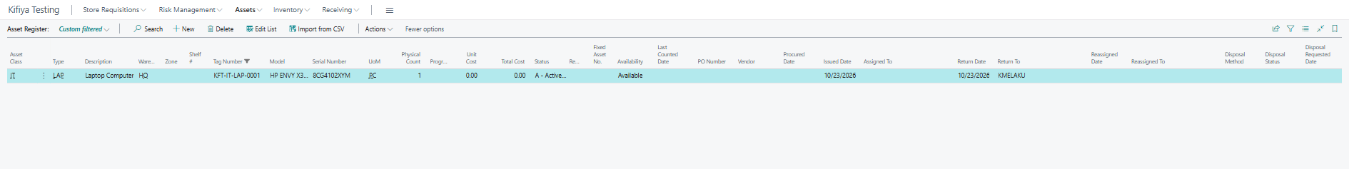
Asset Register after the return: the laptop is back to Available, Assigned To is cleared, and Return Date and Return To (the store keeper) are filled in.

Consumables (paper, pens, toner) are not returned: they are used up when issued. The custody row stays as a record of who received them.

8.1 Issue and Return History
Every issue and return is kept, so you can see who had what and when. Open it from the Store Operations menu: Issue and Return History.
- Each row is one issue: the employee (number and full name), the item or asset with its Tag No., the quantity, the store it came from, the requisition, who approved it and who issued it.
- The Date Returned and Returned To columns fill in when it is taken back. A row with no return date is still with the employee.
- To see everyone a single asset has been issued to, open the Asset Register, select the unit, and click Issue and Return History in the Actions menu.
- An asset can be issued to employee A, returned, issued to B, returned, then issued to C. Each issue is its own row, so the whole chain is kept.
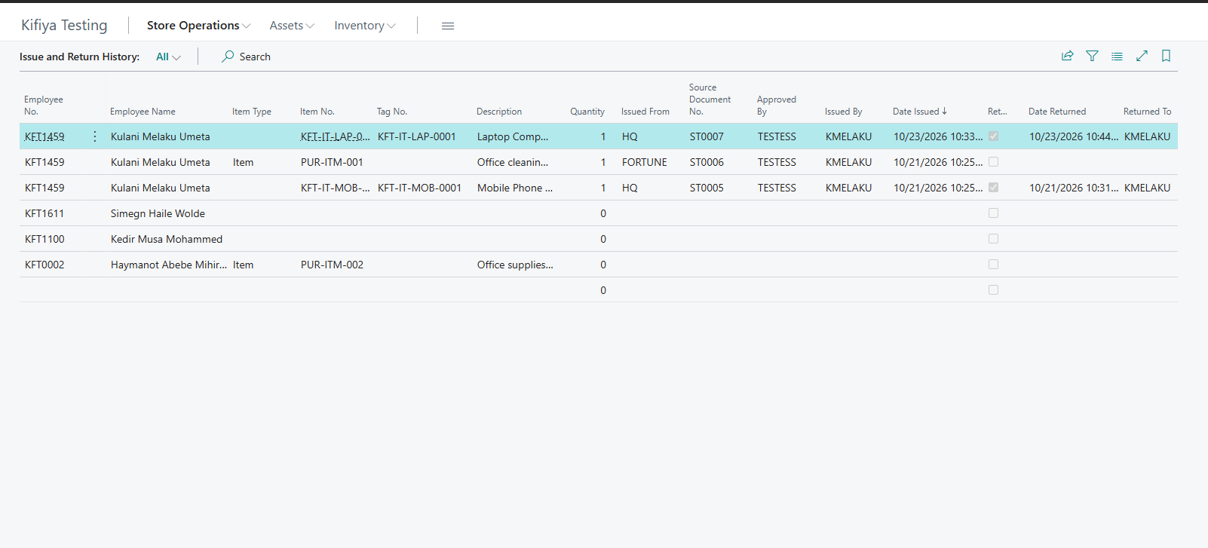
Issue and Return History: the laptop was issued to the employee under ST0007 and returned the same day. Consumables (soap) show as issued with no return, because they are used up.

9. Moving an asset to another person or location (Asset Transfer)
A transfer is raised from the Asset Register for one tagged unit. It can move the unit to another location, hand it to another employee, or both.
- Open Asset Register, select the unit, and click Transfer Asset in the Actions menu. (Or open Asset Transfers and click New, then pick the Tag No.)
- On the transfer card choose where it goes: To Location (with Zone and Shelf if known), and/or To Employee No. for a handover. Add the Reason and whether it is Expected Back.
- The Store Manager opens the transfer and clicks Confirm Transfer. The person who raised it cannot confirm it.
- The store keeper hands the asset over and clicks Transfer.
Case | What the system does
New location only | The Asset Register row moves to the new location, zone and shelf
New employee (asset already issued) | The previous holder custody row is closed today and a new one opens for the new employee. The register shows the new holder, with Reassigned Date and Reassigned To. The Issue and Return History keeps the whole chain
New employee (asset in the store) | Refused. Issue it from a store requisition instead

Asset Register Actions menu: Transfer Asset.
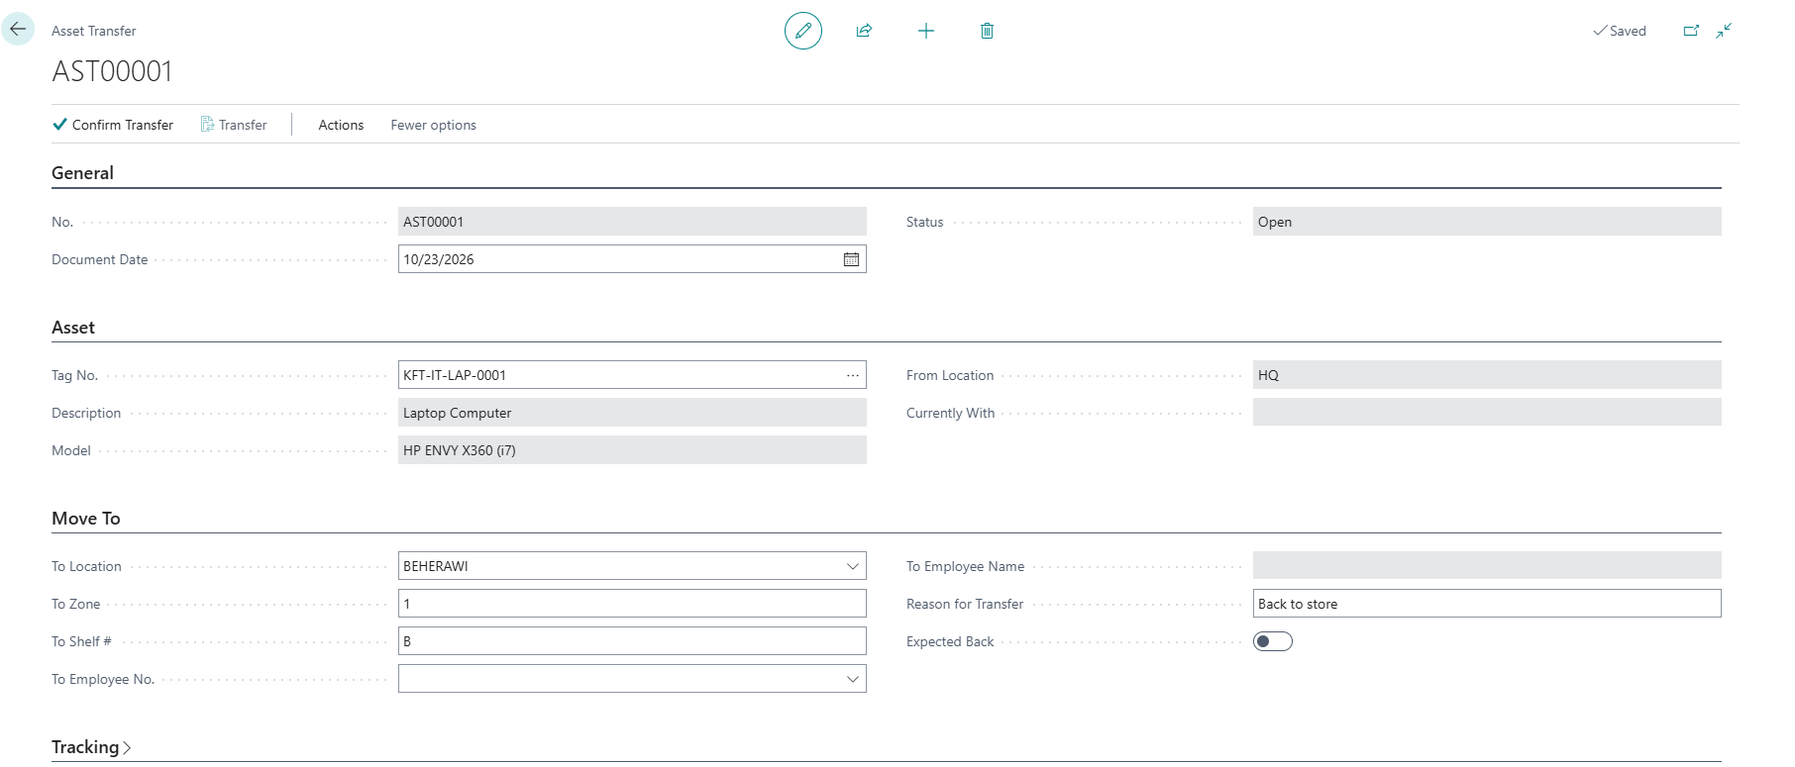
A new transfer: the asset (picked by Tag No.), where it is now, and where it goes (location, zone, shelf and/or a new employee), with the reason. Confirm Transfer is available to the Store Manager.
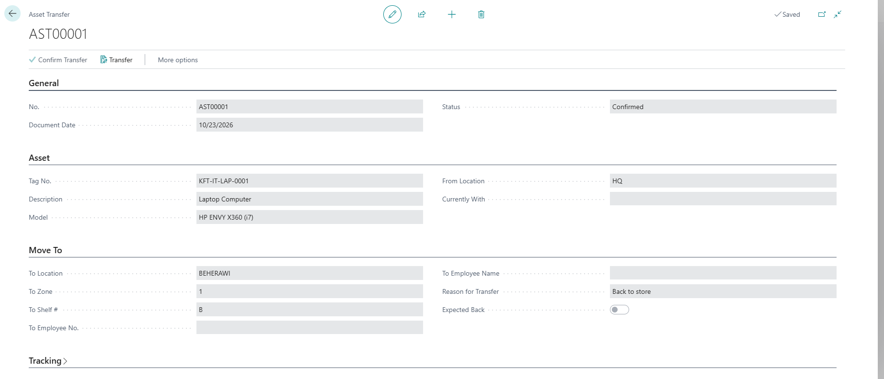
After the Store Manager confirms: the status is Confirmed and Transfer is now available to the store keeper.
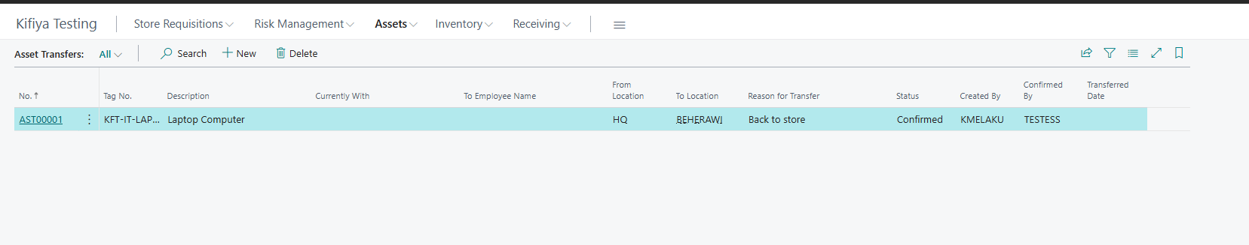
The Asset Transfers list: each transfer with its tag, where it goes, the reason, its status, and who created and confirmed it. The Transferred Date fills in once the store keeper carries it out.
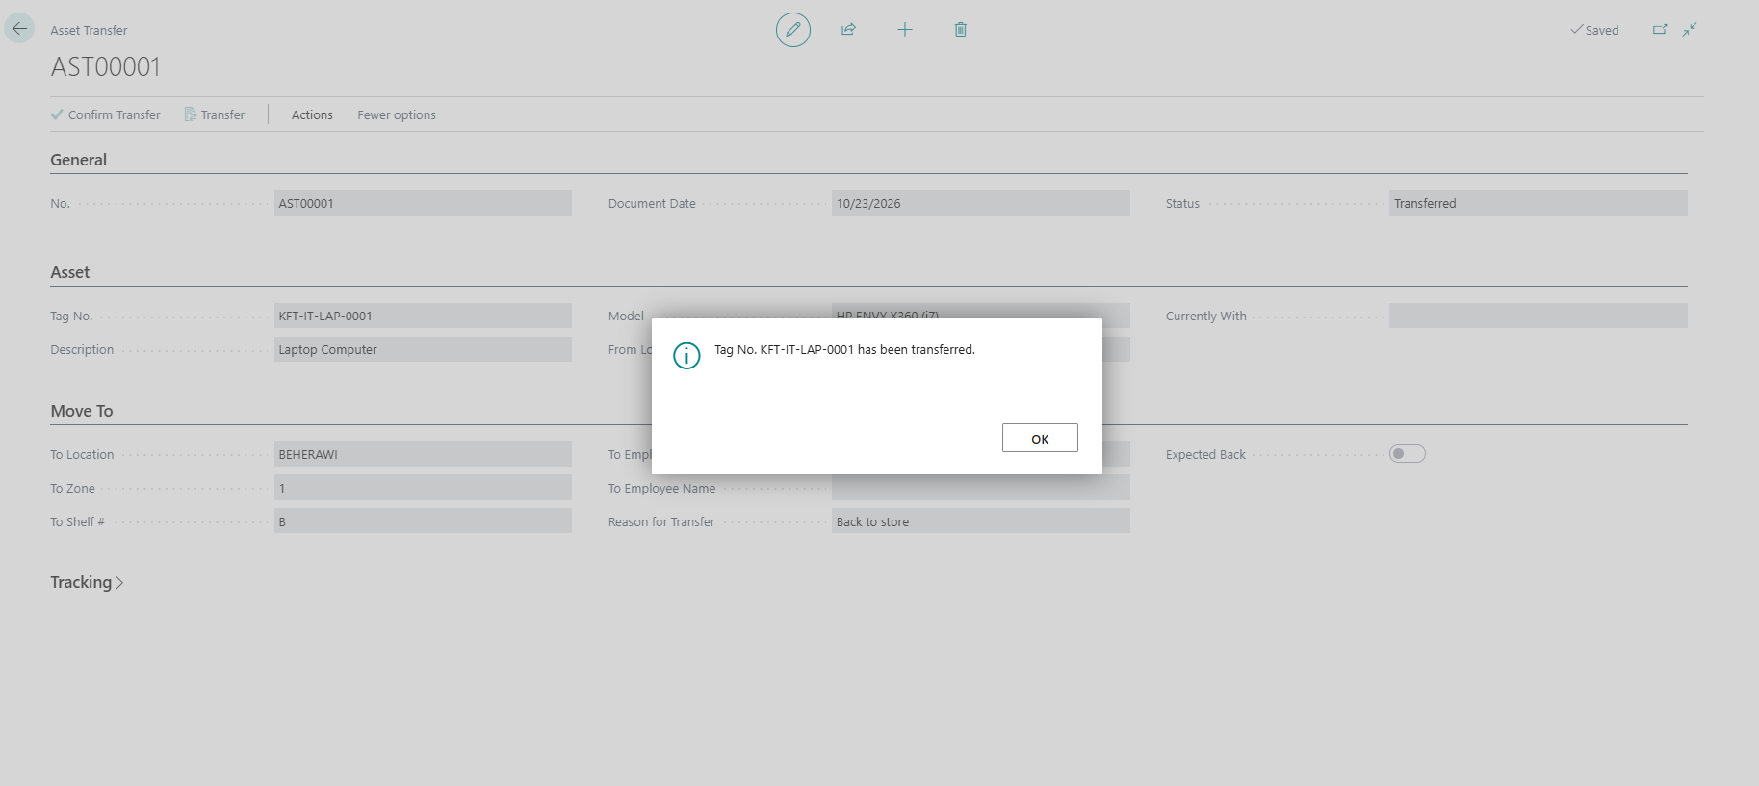
The store keeper clicks Transfer: the message confirms the unit has been transferred, and the status becomes Transferred. The Asset Register row now shows the new location, zone and shelf.

The old Fanisi Asset Transfer only worked on Fixed Asset cards and did not update the Asset Register. Use this one instead.

10. Disposal of an asset
- Open Asset Register and select the asset row.
- Set Disposal Method.
- Click Request Disposal. Disposal Status becomes Pending Approval.
- An Asset Disposal Approver (not the Store Keeper) opens the same list and clicks Approve Disposal or Reject Disposal.
- The disposal takes effect only after approval. Finance handles the accounting.
Asset Register Actions menu: Request Disposal, then Approve Disposal or Reject Disposal (approver only).

11. Physical stock count (periodic)
- Count consumables, enter Physical Count, review Variance (section 4.3).
- Count assets by Tag No. and Mark Counted Today (section 5.4).
- For stock held on Item cards, open Items and compare Inventory with the shelf.
- Enter counted quantities in the Phys. Inventory Journal. Do not post it: the Store Manager reviews and posts adjustments.
- Give the Store Manager the list of variances with reasons.
[ SCREENSHOT ]
Phys. Inventory Journal with counted quantities entered.

12. Daily checklist
- Check the role-centre tiles for new requisitions and GRNs waiting.
- Deliveries: Generate/Create GRN, complete lines, Confirm GRN, shelve and tag.
- Requisitions: open approved ones, check stock, select Tag No., hand over, Post.
- Returns: inspect, Return Item, shelve.
- End of day: tidy the store and spot-check a line or two (Physical Count vs Quantity).

13. Rules to remember
- Never issue without a Store Manager-approved and posted Store Requisition. Never receive without a GRN.
- Always pick the Tag No. for assets so the system tracks who has what.
- Do not create Item or Fixed Asset cards. Ask Finance.
- Do not post depreciation, disposals or stock adjustments. Those belong to Finance and the Store Manager.
- Do not edit quantities to make a variance disappear. Report it.
- Never share your password. Everything you post is recorded against your user ID.

14. Quick reference: where to click
I want to... | Click
Receive a delivery | Home page tile Approved Purchase Orders > open the order > Print/Send > Create GRN (or tile Purchase Invoices Ready > open > Process > Create GRN)
Finish a GRN | Goods Received Notes > open > fill lines > Confirm GRN
See consumable stock | Inventory Register
See asset units | Asset Register / Asset Register Summary
Tag assets | Asset Register > Split into Tagged Units / Generate Tag No.
Issue to an employee | Employee creates requisition > Store Manager: Approve for Issue > Store Keeper: Post Store Requisition
Take something back | Items Issued to Staff > select row > Return Item
Move an asset | Asset Transfers > Confirm Transfer > Transfer
Dispose of an asset | Asset Register > Request Disposal
Count stock | Inventory Register / Asset Register > Mark Counted Today

